**Bahria University, Lahore Campus**

Department of Computer Sciences

Lab Journal 07

**(Fall 2023)**

|  |  |  |
| --- | --- | --- |
| Course: | **Database Management System Lab** | Date: |
| Course Code: | CSL 220 | Max Marks: 10 |
| Faculty’s Name: |  | Lab Engineer: |

Name: ____________________________________ Enroll No: _______________________

# **Lab 7: SQL Case Study**

**Instructions for the Case Study :**

Perform the given queries using any RDBMS Environment.

Suitable tuples have to be entered so that queries are executed correctly

**Scenario**

A bank has many branches and a large number of customers. Bank is identified by its code.

Other details like name, address and phone for each bank are also stored. Each branch is identified by its bank. Branch has name, address and phone. A customer can open different kinds of accounts with the branches. An account can belong to more than one customer. Customers are identified by their SSN, name, address and phone number. Age is used as a factor to check whether customer is a major. There are different types of loans, each identified by a loan number. A customer can take more than one type of loan and a loan can be given to more than one customer. Loans have a duration and interest rate. Make suitable assumptions and use them in showing maximum and minimum cardinality ratios.

create table bank12

( code int primary key ,

bank_name varchar(50),

b_address varchar (50)

);

create table customer128

(

ssn varchar (50) primary key ,

c_name varchar (50),

phone_num int,

c_address varchar (50)

);

create table branch128

(

branch_id int primary key,

b_code int foreign key references bank12(code),

branch_name varchar (50),

branch_address varchar (50)

);

create table account12

(a_num int primary key ,

a_type varchar (50),

a_balance int

);

create table loan12

(loan_id int primary key

,loan_type varchar (50),

loan_amount int

);

create table customeraccount

(

c_ssn varchar (50) foreign key references customer128(ssn) ,

c_a_num int foreign key references account12(a_num)

);

create table customerloan

(

c_l_ssn varchar(50) foreign key references customer128 (ssn),

c_l_id int foreign key references loan12(loan_id)

);

insert into customer129 values(123,'ahmad',003,'lahore')

insert into customer129 values(456,'affan',012,'lahore')

insert into account128 values(1,'joint',3000)

insert into account128 values(2,'joint',6000)

insert into loan12 values(1,'take',2)

insert into loan12 values(2,'take',1)

insert into customerloan1 values(123,1)

insert into branch129 values(1,'alb','lahore')

**Queries:**

1. List the details of customers who have joint account and also have at least one loan.

select * from customer128 ; select a_type from customerloan1 cl ,account128 c,loan12 l

where c.a_type='joint'

and l.loan_amount in ( l.loan_amount )

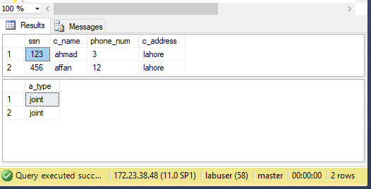

1. List the details of the branch which has given maximum loan.

c) List the details of saving accounts opened in the SBI branches located at Bangalore.

d) List the name of branch along with its bank name and total amount of loan given by it.

e) Retrieve the names of customers who have accounts in all the branches located in a specific city

**Lab Grading Sheet**

|  |  |  |  |
| --- | --- | --- | --- |
| **Task** | **Max Marks** | **Obtained Marks** | **Comments(*if any*)** |
| 1. | 10 |  |  |
| 2. |  |  |  |
| 3. |  |  |  |
| 4. |  |  |  |
| **Total** | **10** |  | **Signature** |

* **Note : Attempt all tasks and get them checked by your Lab. Instructor**